Sql Server data types en equivalent data types in C#

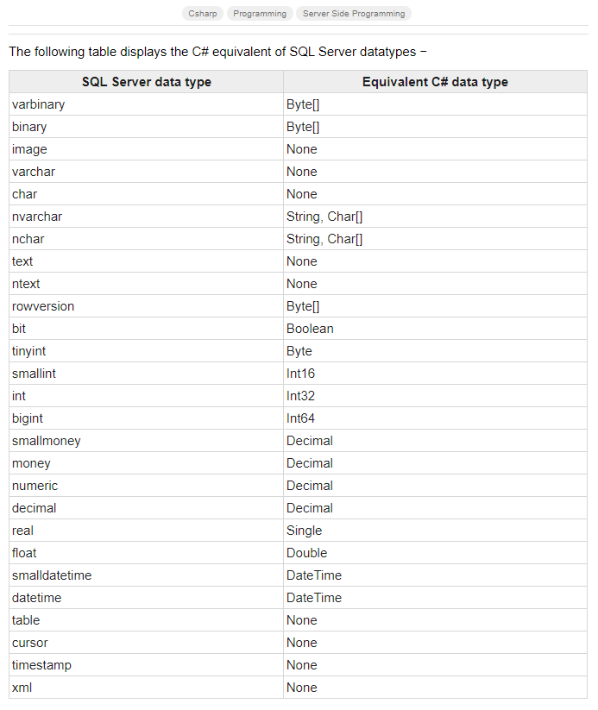

<https://www.tutorialspoint.com/What-is-the-Chash-Equivalent-of-SQL-Server-DataTypes>